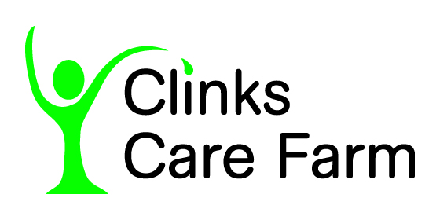
Farm Therapy
Referral form

Farm Therapy is suitable for people
- With mild to moderate mental health issues, burn out, long covid and stress related illness
- Willing to work on recovery
- Who have no significant mobility issues – this is a farm environment with risks of trips and falls
- Who are happy to be outdoors
- Who do not have other needs such as a significant learning disability
- Over 17 years old

Your details

Name: DoB
Address:
Telephone number: Mobile Number
Email address:
Ethnicity Asian: Asian-British: Black – African: Any other Black Background:: Black-British:
Black-Caribbean:: Chinese: White: Any Other White Background: Any Other Ethnic Group:
Do not wish to answer:

Background Information

Employment History (paid and unpaid work)

Are you currently (please tick which applies to you)
- Working
- Off sick
- Unemployed
- Other

Hobbies and interests

Mental health history or other diagnosis?

Any drug and alcohol problems?

Any physical health problems we should be aware of?

What medication do you take?

Will you carry medication on you? Yes/No

What are you hoping to get out of participating in Farm Therapy?

GP Name and address

Do you see anyone else in relation to your mental health? If ‘yes’ please specify
Are you filling this form out on behalf of someone? Please provide name, relationship and contact details here
Farm therapy costs £50 per session. Concessions are available for those on a low income. Tick here if this may apply to you
I agree to Clinks Care Farm keeping my details whilst participating in farm therapy

Signed: Date:

For further information or queries, please contact us on 01502 679134 or per e-mail: admin@clinkscarefarm.org

Thank you for completing this form. Please return to:
Admin
Clinks Care Farm
Church Road, Toft Monks
Beccles NR34 0ET

